  Sanitysoftwares  Branch 1: East Boring Canal Road Behind Laxmi Inn Hotel,Near Reliance Trends, Rajapul, Patna (Bihar).  India-649221  contact: 9708046126 , 9708269608  Email: info@sanitysoftwares.com  Web: https://www.sanitysoftwares.com/  GSTIN: 43553 |  |  | Tax Invoice
 |  |  | Invoice No |  |  |  | ST18-081
 |  |  | Invoice Date |  |  |  | 18-08-2023
 |  |  | State Code |  |  |  | BIHAR
 |  |  | Clint Id |  |  |  | AN423
 |  |  | terms of payment 15 days credit
To
Abhishek
Municipal Chowk , Chapra Contact: 8873007858
SN | Desciption | HSN/SAC  Code |  | Qty | Price |  |  | Tax | Total
1  2  3 | Website development Website hosting  Website digital marketing |  |  |  | 6000  1000  6000 |  |  | 0.00%  0.00%  0.00%
Amount In Words Sub Total 30,338.98
Indian Rupees Thirty Five Thousand Eight Hundred Only CGST 9 Tax(9.0%) 2,730.51
SGST 9 Tax(9.0%) 2,730.51
Round Off 0.00
Total Amount 35,800.00
Amount Paid 5,000.00
Balance Amount 30,800.00
Declaration  1 Payment Terms Against Dellivery  2. GST Application per HSN tratfic code  3 Other Vallaity 30 Days from the date of offer. |  |  |  |  |  | For Lgnite MindZ Pvt Lid (isn cartified),  Authorized Singnatury
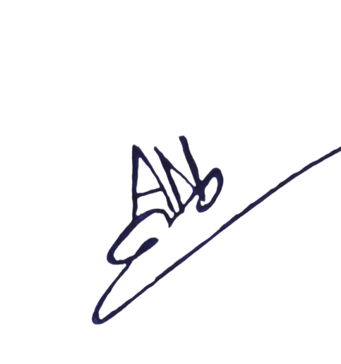
This is a Software Generated Invoice.

